[Name] Tribe Of Issachar 2

[Mobile] 0707 308 5220

AIM AND OBJECTIVES;

1. To fulfill the Great Commission through soul-winning and discipleship, expanding God's kingdom and de-populating the kingdom of darkness.

2. Collaborate with ministers who share the same passion and burden for soul-winning.

3. Prioritize soul-winning and evangelism in all aspects of the ministry.

4. Nurture and disciple new believers to grow in their faith.

5. Reach across denominational lines to spread the Gospel.

6. Organize crusades and events in strategic locations to share the Good News.

7. Support and encourage one another in the ministry, celebrating joys and sharing burdens.

8. Engage in community service and providing basic medical needs/welfare.

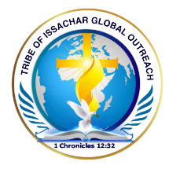

TRIBE OF ISSACHAR GLOBAL OUTREACH

This Is To Inform The General Public That The Above Named Has Applied

To The Corporate Affairs Commission For Registration Under Part C Of The

Companies And Allied Matters Act Of 1990.

The Trustees Are:

1. Kamanya Ifeoma Jane – Chairman

2. Opara Yagazie Kosisochukwu – Secretary

Aims And Objectives

1. To Fulfil The Great Commission Through Soul-Winning And Discipleship,Expanding God’s Kingdom And De-Populating The Kingdom Of Darkness.

Any Objection On This Registration Should Be Forwarded To The Registrar

General, Corporate Affairs Commission Plot 420 Tigris Crescent, Off

Aguiyi Ironsi Street Maitama, Abuja Within 28 Days From The Date Of This

Publication.

Signed: The Secretary

Motto: passion for lost souls

Social Media handles:

Tribeofissacharglobaloutreach@gmail.com

Instagram: Tribeofissachar1

Facebook: Tribe Issachar

Tiktok: tribeissachar

Links:

Home

About

- tribe of Issachar

- board of trustees

Sermons:

- videos

- audio

- pictorial reference

Books

- pdf

Continue:

Events:

- upcoming events

Where the admin can post daily messages/ quotes.

Good morning, mighty soldiers of the Lord.

Our website is nearing completion, but we still need a few of you to submit your photos and biographies. As members of this board, it’s important that everyone is represented.

The developer is ready to finalise the site, and we need your contributions by tomorrow. Please ensure you’re included in this process.

God bless us abundantly. Shalom.

The admin in charge posted this in their platform because we told her 2weeks. So she's calculating from her end.

Angwai Happiness Nseobong is an Evangelist and a minister in rccg . she gave her life to christ 2006.God always used her to minister in songs to deliver the oppressed , she is currently the choir leader in Almighty parish lakwe Lagos,she was ordained as Deaconess in rccg in August 5th 2021.she has successfully completed the training in catering craft in rccg vocational institute (Region xi) jakande Lagos.

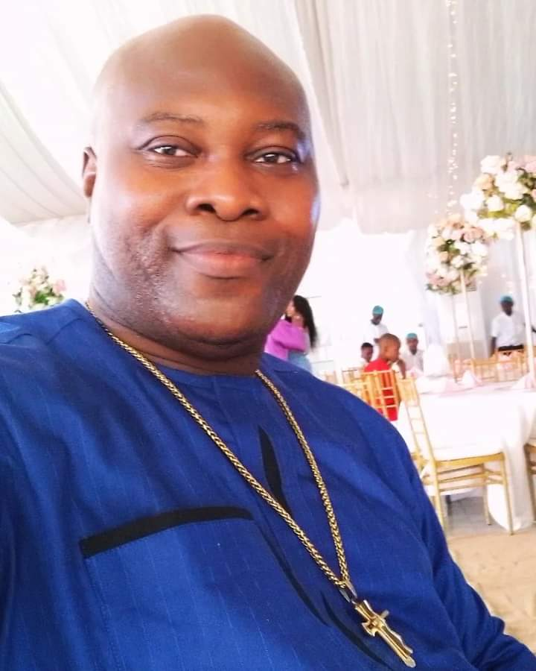Apostle Dr. Kennedy Odiakaose is the founder of Judah's Crib Ministry. He is an apostolic intercessor with an outreach ministry to win souls and build the body of Christ. Dr. Odiakaose has been in the ministry for 24 years, touching lives and preaching the gospel of life and immortality. His vision is to see men become gods through the divine word of God! He is married.

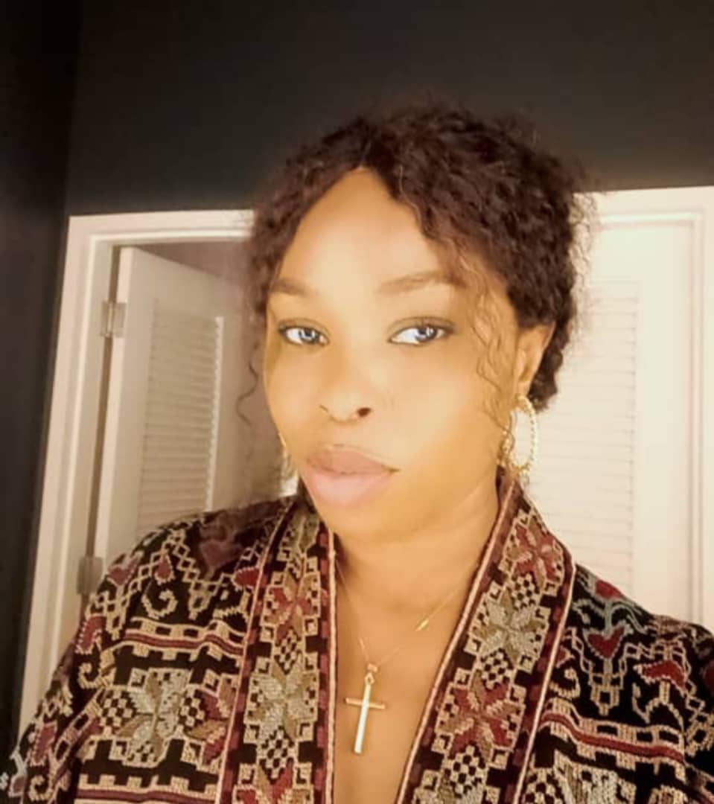My name is Anulika Mojekwu, founder of anulikalifefoundation and also a senior partner with "The family word centre"

I am from Anambra State, studied business administration from Enugu State University and a certified fashion stylist from London school of dress making and design .

A certified oil and gas lead document controller for 13 years but presently a counsellor,life coach ,youth pastor and Teacher of the word .

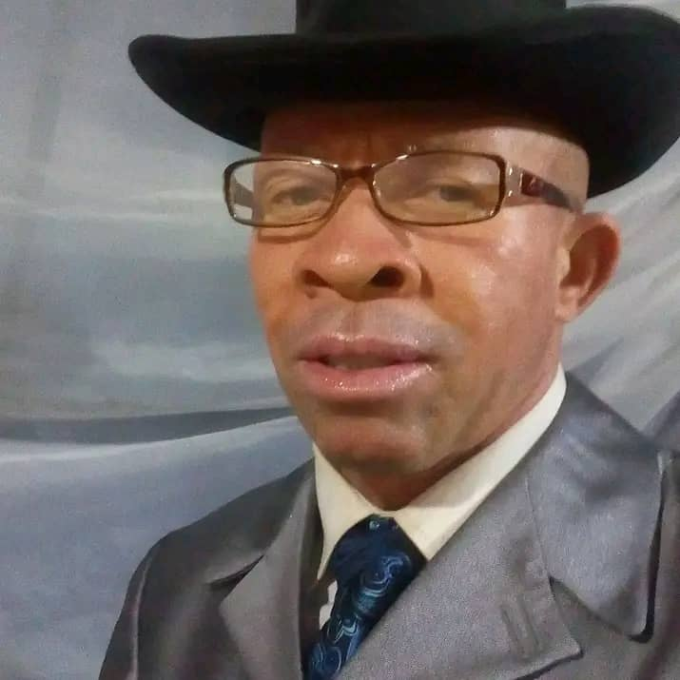BISHOP SIMON ENYIOMA OKIKE IS A DYNAMIC PREACHER. HE MET CHRIST IN 1989 .

AFTER HIS CONVERSION SIMON ENYIOMA OKIKE HAS REMAIN A PREACHER OF GOD'S WORD, CURRENTLY ,HE IS THE PRESIDING BISHOP OF CITY OF DELIVERANCE BIBLE CHURCH ( A.K.A HOUSE OF PRAYER ) .

AREPO OGUN STATE, IKORODU LAGOS STATE. THE HOLY SPIRIT HAS BEEN USING HIM TO MINISTER HEALING AND DELIVERANCE TO PEOPLE, SUFFERING FROM DEMONIC ACTIVITIES.

Board of trustees and profiles

Books 📚 to be download free

Other books may come in later

But remember there will have to be uploading other files by themselves later on..

Like audios, books videos,images and upcoming events (text) [10:00 AM, 9/3/2024] Kris Citi Poly: Books 📚 to be download free

Other books may come in later

But remember there will have to be uploading other files by themselves later on..

Like audios, books videos,images and upcoming events (text)

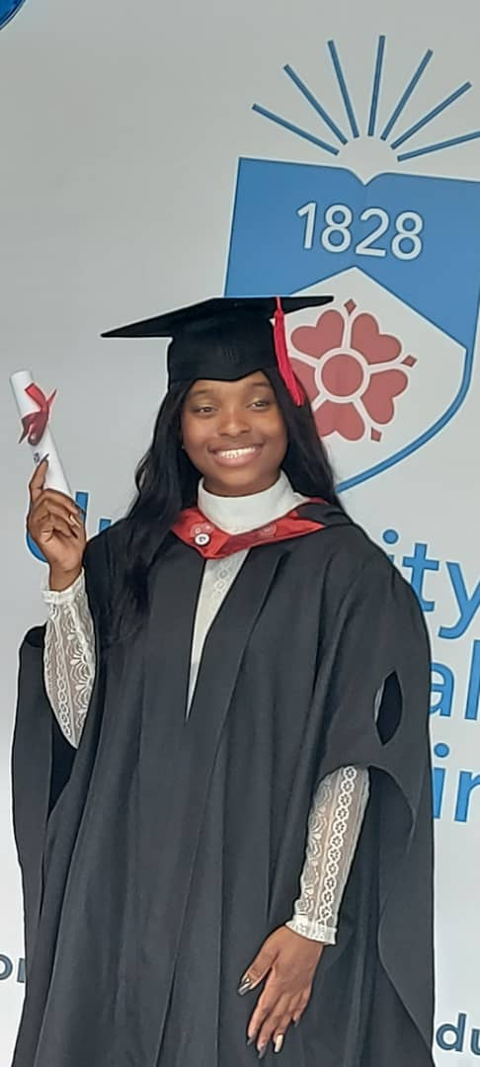My name is Evangelist Yagazie Phelan. I studied BA Hons Business Studies at the University of Central Lancashire and studied my masters at The University of Hull. I am currently married and settled in Hull in the United Kingdom, and I am devoted to following Christ Jesus. He is my LORD and Saviour.

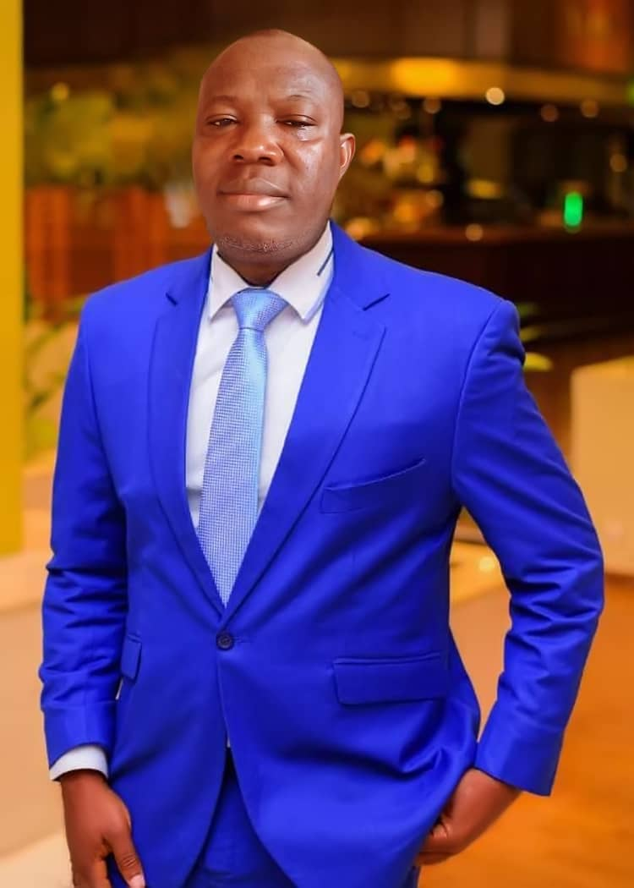My name is prophet Ola James Adeniyi

The president the SURE FOUNDATION MINISTRY which is the prophetic and Deliverance ministry and also the President of FIREDRAM EVANGELICAL MINISTRY which is the Drama ministry that birthed in the month of April 29 1998 sangotedo Lagos but I was fully ordained in the office of a prophet with license in November 2021.

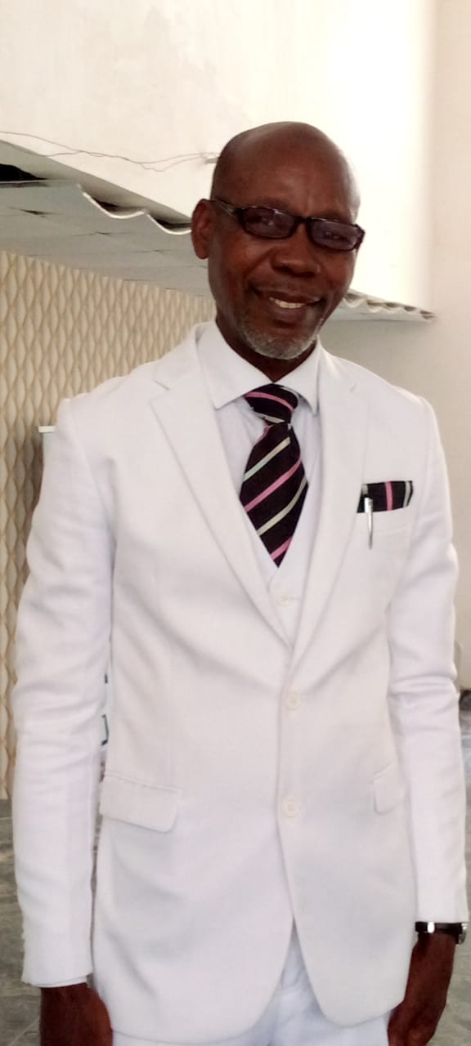 Apostle Nwoha Kingsley Ichechukwu Is a dynamic preacher, I met Christ in 1996 . After my conversion Nwoha Kingsley Ichechukwu has remained a preacher of God's word, currently I'm the president of THE POWER of God INl'T CHURCH (AKA) THE ARENA Of GOD'S PRESENCE, oka gun EpE Express Ibeju lekki LAGOS STATE. IAM MARRIED

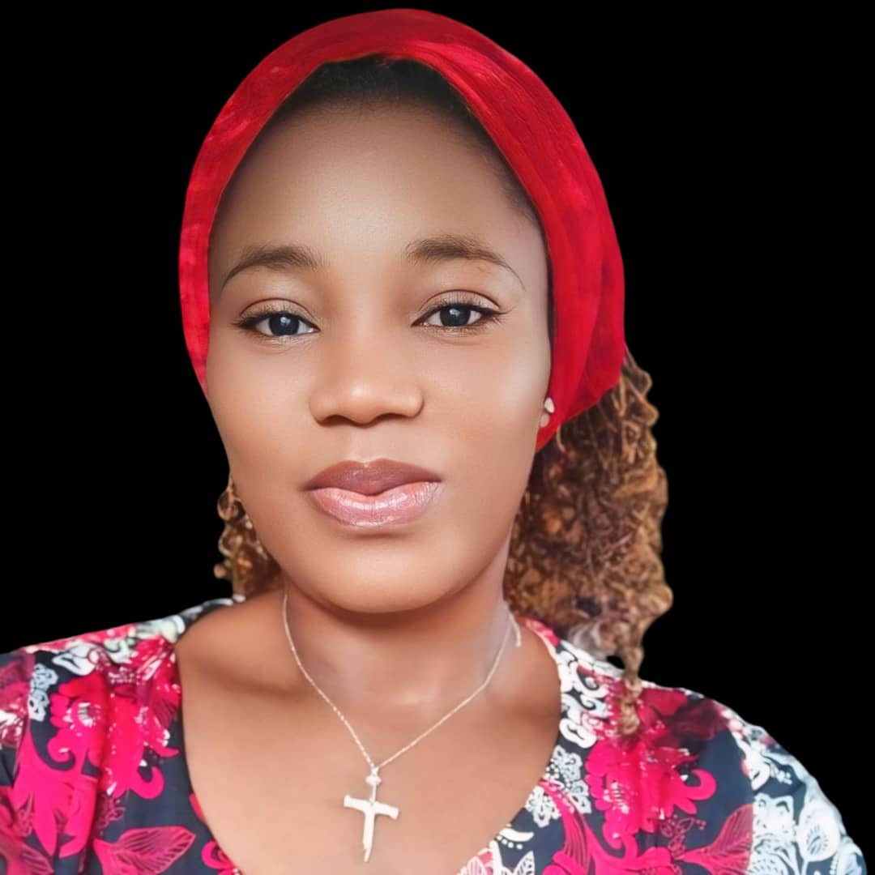Evang. Helen Olusola Sowunmi

Brief Profile:

Evang. Helen Olusola Sowunmi is a multifaceted individual, blending scientific expertise with spiritual passion. A trained scientist and experienced teacher, she has also undergone rigorous Evangelism/Ministerial training, empowering her to effectively spread the Gospel.

In the year 2000 Evang. Helen surrendered her life to Christ, embracing Him as her Savior and Lord. Since then, she has diligently served in various church capacities, honing her leadership skills. Her ministerial expertise spans Nigeria and Benin Republic. Currently, she serves as a dedicated minister at Glory Nation Ministries.

Evang. Helen resides in Ijebu Ode, Ogun State, with her loving family.

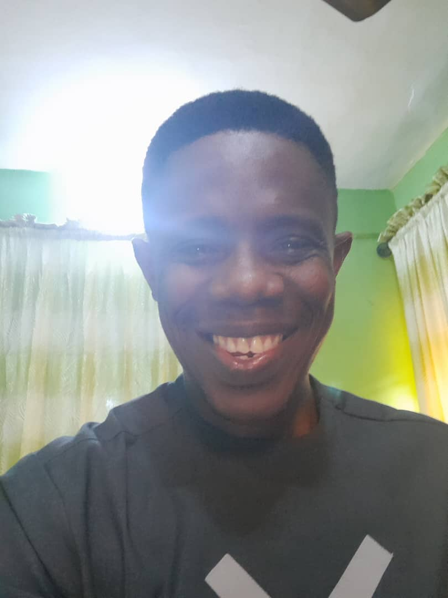 RICHARD USORO is a trader who loves Jesus.

He read Business Management and Administration at the University of Uyo and works for commodity trading firm in Lagos.

He is passionate about expanding the frontiers of God's kingdom through the work of Evangelism and Missions.

He attends Trinity House Church and is also a team member of the Tribe of Isachar outreach.

 RICHARD USORO is a trader who loves Jesus.

He read Business Management and Administration at the University of Uyo and works for commodity trading firm in Lagos.

He is passionate about expanding the frontiers of God's kingdom through the work of Evangelism and Missions.

He attends Trinity House Church and is also a team member of the Tribe of Isachar outreach.

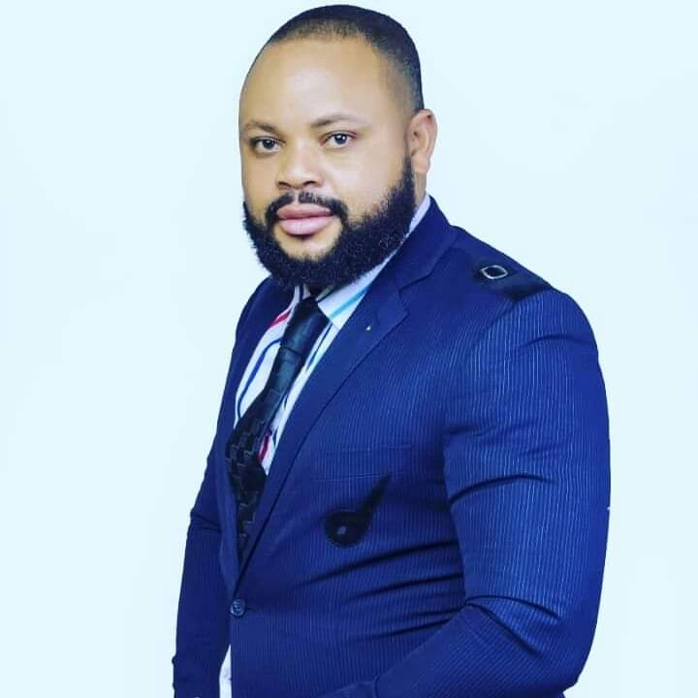Biography:

My Names are Prophet Michael Chibuisi Okogeri

Am a Servant of Yahweh ..Ministering As A Prophet, Preacher, Deliverance Minister, Evangelist etc, In Christ Redemption Church Located at Faith and Favor Street, Beside UBA Supermarket Bus Stop, Awoyaya, Ajah, Lekki, Lagos, Nigeria. I am a Prophetic Child as my coming to the Earth was revealed to my Mother by Prophecy and my Name : Chibuisi ( God Is The Head ) was given to her as the Name she must give to me . So from Childhold till now in been serving